**ASSIGNMENT 3**

|  |  |
| --- | --- |
| **DATE** | 13th September 2022 |
| **ROLL NUMBER** | 2019503057 |
| **NAME** | THILAKSURYA B |
| **TEAM ID** | PNT2022TMID35662 |

1. **Create a Bucket in IBM Object Storage.**

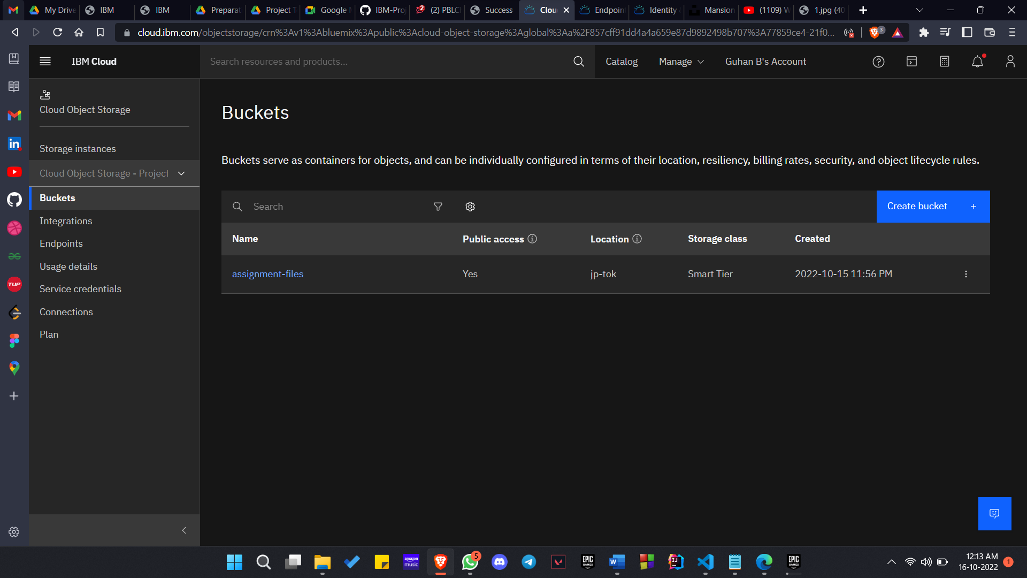

1. **Upload 5 images to IBM Object Storage Bucket and make it public. Create a HTML page and display these 5 images.**

**SOURCE CODE**

<!DOCTYPE html>

<html lang="en">

<head>

    <meta charset="UTF-8">

    <meta http-equiv="X-UA-Compatible" content="IE=edge">

    <meta name="viewport" content="width=device-width, initial-scale=1.0">

    <title>Gallary</title>

    <link rel="stylesheet" href="style.css">

</head>

<body>

    <div class="container">

        <h1>Image Gallary</h1>

        <div class="wrapper">

            <img src="https://assignment-files.s3.jp-tok.cloud-object-storage.appdomain.cloud/1.jpg" alt="Image 1">

            <img src="https://assignment-files.s3.jp-tok.cloud-object-storage.appdomain.cloud/2.jpg" alt="Image 2">

            <img src="https://assignment-files.s3.jp-tok.cloud-object-storage.appdomain.cloud/3.jpg" alt="Image 3">

            <img src="https://assignment-files.s3.jp-tok.cloud-object-storage.appdomain.cloud/4.jpg" alt="Image 4">

            <img src="https://assignment-files.s3.jp-tok.cloud-object-storage.appdomain.cloud/5.jpg" alt="Image 5">

            <img src="https://assignment-files.s3.jp-tok.cloud-object-storage.appdomain.cloud/6.jpg" alt="Image 6">

        </div>

    </div>

</body>

</html>

**OUTPUT**

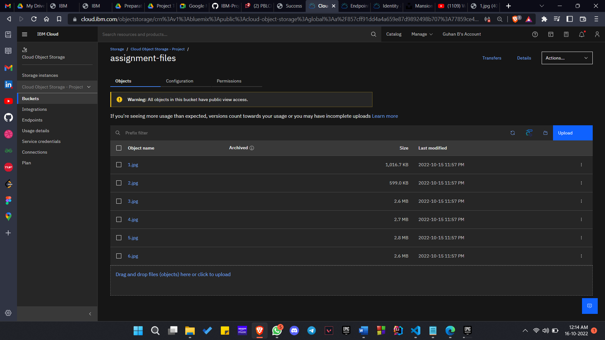

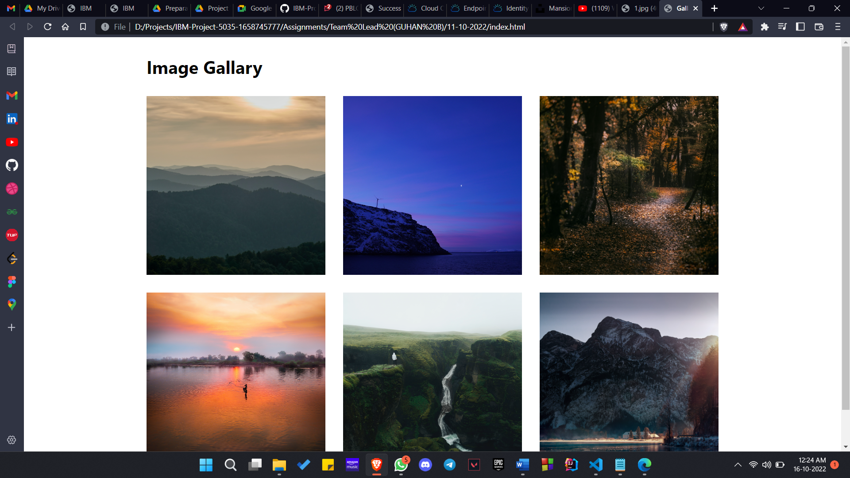

1. **Upload a CSS file to IBM Object Storage Bucket and use it on a HTML page.**

**SOURCE CODE**

index.html

<!DOCTYPE html>

<html lang="en">

<head>

    <meta charset="UTF-8">

    <meta http-equiv="X-UA-Compatible" content="IE=edge">

    <meta name="viewport" content="width=device-width, initial-scale=1.0">

    <title>Gallary</title>

    <link rel="stylesheet" href="https://assignment-files.s3.jp-tok.cloud-object-storage.appdomain.cloud/style.css">

</head>

<body>

    <div class="container">

        <h1>Image Gallary</h1>

        <div class="wrapper">

            <img src="https://assignment-files.s3.jp-tok.cloud-object-storage.appdomain.cloud/1.jpg" alt="Image 1">

            <img src="https://assignment-files.s3.jp-tok.cloud-object-storage.appdomain.cloud/2.jpg" alt="Image 2">

            <img src="https://assignment-files.s3.jp-tok.cloud-object-storage.appdomain.cloud/3.jpg" alt="Image 3">

            <img src="https://assignment-files.s3.jp-tok.cloud-object-storage.appdomain.cloud/4.jpg" alt="Image 4">

            <img src="https://assignment-files.s3.jp-tok.cloud-object-storage.appdomain.cloud/5.jpg" alt="Image 5">

            <img src="https://assignment-files.s3.jp-tok.cloud-object-storage.appdomain.cloud/6.jpg" alt="Image 6">

        </div>

    </div>

</body>

</html>

style.css (<https://assignment-files.s3.jp-tok.cloud-object-storage.appdomain.cloud/style.css>)

* {

    margin: 0;

    padding: 0;

    box-sizing: border-box;

    font-family: 'Segoe UI', Tahoma, Geneva, Verdana, sans-serif;

}

.container {

    width: 70%;

    margin: 2rem auto;

}

.container h1 {

    margin-bottom: 2rem;

}

.container .wrapper {

    display: grid;

    grid-template-columns: 1fr 1fr 1fr;

    gap: 2rem;

}

.container .wrapper img {

    width: 100%;

}

**OUTPUT**

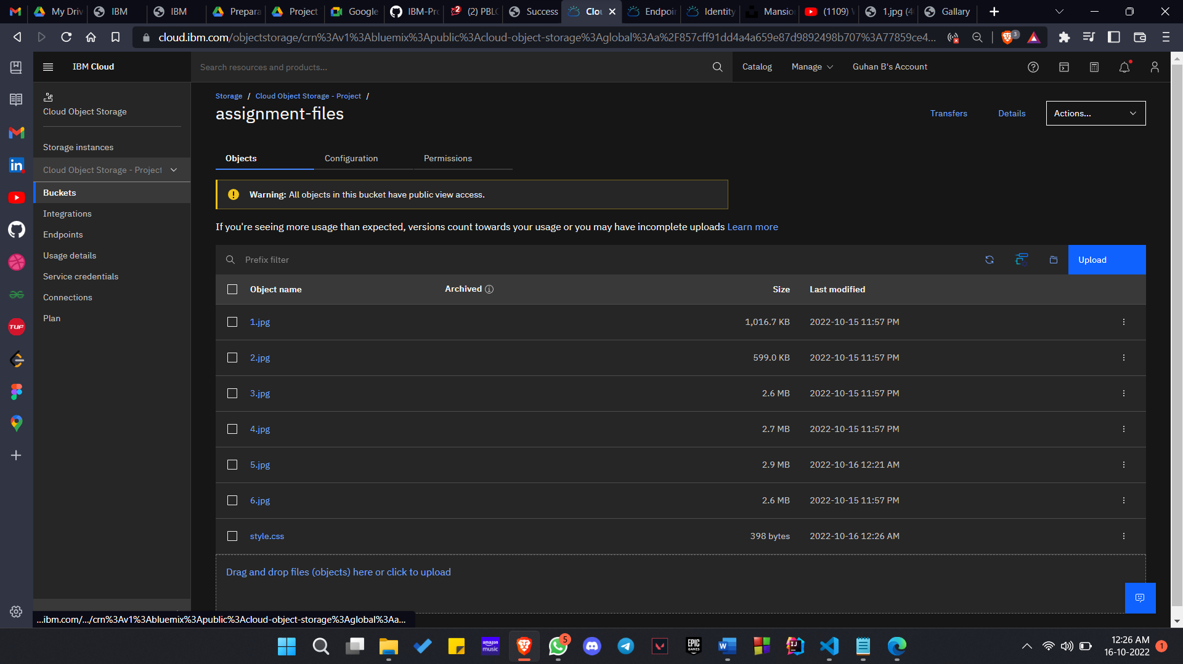



1. **Design a chat bot using IBM Watson for hospital**

<https://web-chat.global.assistant.watson.appdomain.cloud/preview.html?backgroundImageURL=https%3A%2F%2Fus-south.assistant.watson.cloud.ibm.com%2Fpublic%2Fimages%2Fupx-f372cc5f-9aed-455f-809d-962d192b73d2%3A%3A3a8c0257-5c59-40e2-8a73-c8974baba469&integrationID=b1eca765-abeb-4e6b-ba55-9eda9f873503&region=us-south&serviceInstanceID=f372cc5f-9aed-455f-809d-962d192b73d2>

1. **Create a Watson assistant with 10 steps and 3 conditions and load that in HTML page**

**SOURCE CODE**

<!DOCTYPE html>

<html lang="en">

<head>

    <meta charset="UTF-8">

    <meta http-equiv="X-UA-Compatible" content="IE=edge">

    <meta name="viewport" content="width=device-width, initial-scale=1.0">

    <title>Document</title>

</head>

<body>

    <script>

        window.watsonAssistantChatOptions = {

          integrationID: "b34df728-95c8-42f2-b5a0-70259637d699",

          region: "eu-gb",

          serviceInstanceID: "f5f1c292-4028-42f8-bc3b-84c649de4cfa",

          onLoad: function(instance) { instance.render(); }

        };

        setTimeout(function(){

          const t=document.createElement('script');

          t.src="https://web-chat.global.assistant.watson.appdomain.cloud/versions/" + (window.watsonAssistantChatOptions.clientVersion || 'latest') + "/WatsonAssistantChatEntry.js";

          document.head.appendChild(t);

        });

    </script>

</body>

</html>

**OUTPUT**

